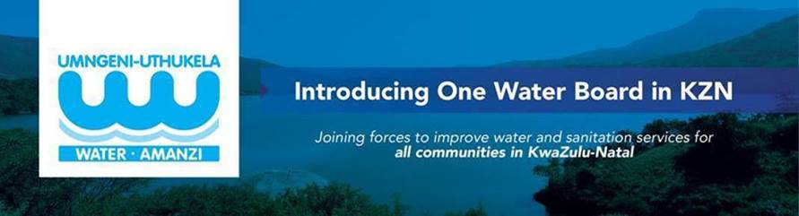

Intention to Award
Tender Number: 2026/061 - Advertised on 17 April 2026 in the National Treasury e-portal, uMngeni -uThukela Water website and Mercury Newspaper
Tender Description: Technical Review of Consolidated Annual Financial Statements and Support for Three Financial Years
Intention to award to: Malte Advisory Inc

Note:

Persons aggrieved by decisions or actions taken by uMngeni-uThukela Water, may lodge an appeal within 7 business days of the date of the intention to award notification.

The appeal (clearly stating reasons for appeal) and queries with regard to the decision of award are to be directed, in writing only to the Supply Chain Management Office, Attention: Supply Chain Management, Email: appeals@uuw.co.za

Note that appeals not addressed to the abovementioned email will not be considered.

