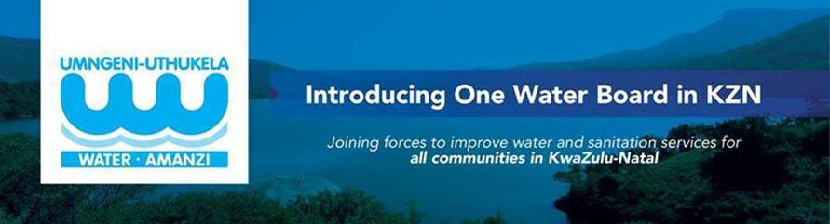

INVITATION TO BID:
SUBJECT: | SUPPLY, DELIVERY AND OFFLOADING OF POWDER ACTIVATED CARBON TO UMNGENI-UTHUKELA WATER
Ref Number: | 2026/033
Date Issued: | 19 March 2026
Closing Date and time : | 23 April 2026 at 12:00
Compulsory Briefing meeting. | Date: 01 April 2026  Venue: Microsoft Teams (The link will be sent upon request)  Time: 11H00
Bid documents obtainable from: | Documents will be downloaded from e-tenders or uMngeni-uThukela website.
Cost of documents | Free issue
Submission place: | Tenders are to be deposited in the Tender Box located outside the main entrance at uMngeni-uThukela Water, 310 Burger Street, Pietermaritzburg.
Contact details | Contact person: Ms. Likho Tima  Contact number :033 341 1217  E-mail address : Likho.Tima@uuw.co.za

