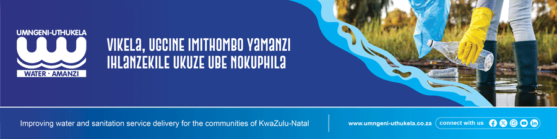
INVITATION TO BID:
SUBJECT: | Mondi Bypass Water Pipeline
Ref Number: | 2025/046
Date Issued: | 06 October 2025
Closing Date and time : | 06 November 2025 at 12:00
CIDB | An active CIDB grading of 6CE or higher is required.
Non-Compulsory Clarification meeting. | A Compulsory clarification meeting with representatives of uMngeni-uThukela Water will take place at, uMngeni-uThukela Water, North East Regional Office, Cnr South Central Arterial & Battery Bank Alton Richards Bay then proceed to site on 14 October 2025 starting at 10:00
Bid documents obtainable from: | Documents will be issued by email, upon request to spha.mthembu@uuw.co.za. Documents will only be issued in electronic format, during working hours from 06 October 2025 to 13 October 2025.
Cost of documents | Free issue
Submission place: | Tenders are to be deposited in the Tender Box located outside the main entrance at uMngeni-uThukela Water, 310 Burger Street, Pietermaritzburg.
Contact details | Contact person: Mr Sphamandla Mthembu  Contact number :033 341 1325  E-mail address : spha.mthembu@uuw.co.za

